# **Initial Methane Production (IMP) differences between *Methanobacterium formicicum* pure culture with and without 0.5 g/L of activated carbon (AC)**

The *M. formicicum* strain used in these assays was DSM 1535 and the proteome of the corresponding database was used for proteomics analysis. The proteome of this strain possess 2393 proteins ([https://www.uniprot.org/uniprot/?query=Methanobacterium%20formicicum%20DSM1535&sort=score#](https://www.uniprot.org/uniprot/?query=Methanobacterium%20formicicum%20DSM1535&sort=score)).

The analysis of the proteins detected was done based on the following criteria: first, it was identified the proteins only detected in each condition (with or without AC) based on the peptide-to-spectrum matchings (PSM) count, which accounts for the situations where PSMs were reported in one condition and not on the another one; and then it was listed the proteins whose peptide spectra were detected in both conditions (with or without AC) but in which the level of expression/detection was different (up and down expression/detection). After this, proteins were grouped by different functions, such as: stress proteins, membrane proteins, cellular involucre proteins, electron transfer proteins, among others.

## **Initial Methane Production phase**

The analysis of proteins detected during the initial methane production phase in each condition (with and without AC) allowed to obtain the following information:

* 138 proteins only detected in *M. formicicum* pure culture without AC (control)
* 59 proteins only detected in *M. formicicum* pure culture with 0.5 g/L AC
* 209 proteins overexpressed in the control condition
* 68 proteins overexpressed in the condition with AC
* 8 proteins not differentially expressed
* 1911 proteins not detected

The differences found between conditions sometimes are not significantly different (e.g., 140 spectra in control vs 145 spectra in AC) and the analysis considered it as overexpressed in AC condition, what cannot be confirmed since there is not replicates. As suggesting, we could establish a threshold and repeat this analysis for 25 % of difference in PSM counting.

## **Krona plots analyses**

Proteins and spectra quantifications were represented in krona plots, along with their COG general function category (COG general), COG functional category (COG functional), COG protein description (COG description) and COG (COG ID) (e.g.: METABOLISM; Energy production and conversion; Pyruvate:ferredoxin oxidoreductase and related 2-oxoacid:ferredoxin oxidoreductases, beta subunit; COG1013; A0A090I6X8).

Two types of representation were obtained:

1. Number of proteins – each protein is assigned the value of 1 in the plot, thus giving the same weight for each protein
2. Weighted – it quantifies the differential expression of the proteins by two different methods, depending on whether the protein was detected on both conditions or only one
   1. Protein was only detected in one condition – the value associated is the PSM count for that protein
   2. Protein was detected in both conditions – the value associated is the % of under/overexpression from control to AC

In a general way, 138 proteins were only detected in control, 209 were underexpressed in AC, 68 were overexpressed in AC and 59 were only detected in AC.

### **Proteins only detected in control assay (pure culture of** *M. formicicum***)**

The COG general categories of the 138 proteins only detected in the control condition without AC were as follows:

* 43 % of proteins from METABOLISM: 12 % were related to *amino acid transport and metabolism*; 10 % to *energy production and conversion*; 9 % to *coenzyme transport and metabolism*; 4 % to *nucleotide transport and metabolism*; 3 % to *carbohydrate transport and metabolism*; 3 % to *inorganic ion transport and metabolism*; 0.7 % to *lipid transport and metabolism*; and 0.7 % to *secondary metabolites biosynthesis, transport and catabolism*;
* 23 % of proteins from INFORMATION STORAGE AND PROCESSING: 15 % were associated to *translation, ribosomal structure and biogenesis*; 6 % to *transcription* and the remaining 2 % to *replication, recombination and repair* and to *chromatin structure and dynamics*;
* 20 % of proteins were classified as POORLY CHARACTERIZED;
* 14 % of proteins from CELLULAR PROCESSES AND SIGNALING: 6 % related to *cell wall/membrane/envelope biogenesis*; 4 % to *posttranslational modification, protein turnover, chaperones*; and the remaining 4 % to *signal transduction mechanisms*, to *intracellular trafficking, secretion, and vesicular transport* and to *defense mechanisms.*

When considering the spectra count, 36 % of spectra detected is for METABOLISM category (which represents the 43 % of proteins mentioned above), while INFORMATION STORAGE AND PROCESSING accounts for 28 % of spectra (with the 23 % of proteins mentioned above), 15 % is for CELLULAR PROCESSES AND SIGNALING, 21 % of the spectra is for POORLY CHARACTERIZED category and some COG description from different pathways stand out in the data.

Table 1 reports the COG categories that were detected with 1 % or more of spectra in the control assay of the pure culture of *M. formicicum* without AC. It needs to be highlighted that when the number of spectra is converted into proteins, more than one different protein could have the same “COG description” (see examples on section 4.1).

**Table 1.** Most relevant “COG description” according to the percentage of spectra only detected in the control assay of M. formicicum pure culture without AC

|  |  |  |  |
| --- | --- | --- | --- |
| COG general | COG functional | COG description | % of spectra detected |
| METABOLISM | Energy production and conversion | Pyruvate:ferredoxin oxidoreductase and related 2-oxoacid:ferredoxin oxidoreductases, beta subunit | 3 |
| Fe-S oxidoreductases | 1 |
| Amino acid transport and metabolism | Transglutaminase-like enzymes, putative cysteine proteases | 2 |
| Coenzyme transport and metabolism | Delta-aminolevulinic acid dehydratase | 2 |
| Carbohydrate transport and metabolism | 2-phosphoglycerate kinase | 1 |
| Lipid transport and metabolism | Acyl-coenzyme A synthetases/AMP-(fatty) acid ligases | 2 |
| INFORMATION STORAGE AND PROCESSING | Translation, ribosomal structure and biogenesis | Ribosomal protein L19E | 2 |
| Ribosomal protein S4 and related proteins | 2 |
| Prolyl-tRNA synthetase | 2 |
| Predicted exosome subunit | 1 |
| Ribosomal protein L16/L10E | 1 |
| Transcription | Transcriptional regulators containing a DNA-binding HTH domain and an aminotransferase domain (MocR family) and their eukaryotic orthologs | 2 |
| Transcription initiation factor TFIIIB, Brf1 subunit/Transcription initiation factor TFIIB | 2 |
| Replication, recombination and repair | DNA topoisomerase VI, subunit B | 2 |
| CELLULAR PROCESSES AND SIGNALING | Cell wall/membrane/envelope biogenesis | Predicted phosphosugar isomerases | 3 |
| Nucleoside-diphosphate-sugar epimerases | 1 |
| Nucleoside-diphosphate-sugar pyrophosphorylase involved in lipopolysaccharide biosynthesis/translation initiation factor 2B, gamma/epsilon subunits (eIF-2Bgamma/eIF-2Bepsilon) | 1 |
| ATPases of the AAA+ class | 2 |
| Signal recognition particle GTPase | 2 |
| Total | | | 34 |

### **Proteins under-expressed in the presence of Activated Carbon (AC)**

The percentage of proteins within the next COG general categories were evaluated as under-expressed in assay with AC:

* 41 % of proteins from METABOLISM: 13 % were related to *energy production and conversion*; 10 % to *amino acid transport and metabolism*; 8 % to *coenzyme transport and metabolism*; and the remaining 10 % of proteins are distributed by *nucleotide transport and metabolism*, *lipid transport and metabolism*, *inorganic ion transport and metabolism* and *carbohydrate transport and metabolism* COG functional categories;
* 22 % from INFORMATION STORAGE AND PROCESSING: 16 % related to *translation, ribosomal structure and biogenesis*; 4 % to *transcription* and the remaining 2 % to *replication, recombination and repair*;
* 20 % of proteins were classified as POORLY CHARACTERIZED;
* 17 % from CELLULAR PROCESSES AND SIGNALING: 7 % related to *posttranslational modification, protein turnover, chaperones*; 5 % to *cell wall/membrane/envelope biogenesis*; and the remaining 5 % to *cell cycle control, cell division, chromosome partitioning*, to *signal transduction mechanisms* and to *defense mechanisms.*

Table 2 contains the proteins (“UniProt ID”) identified in the control assay of *M. formicicum* without the material that suffered an under-expression of over 65 % when AC is present in the assay. For example, the protein A0A090I3L1 was expressed less 88 % when AC is present in the environment (59 PSM in control vs 7 PSM in AC):

**Table 2.** Proteins UniProt ID with over 65 % under-expression in AC assay comparing with control assay without AC

|  |  |  |  |  |
| --- | --- | --- | --- | --- |
| COG general | COG functional | COG description | UniProt ID | % of under-expression |
| METABOLISM | Lipid transport and metabolism | Acyl-coenzyme A synthetases/AMP-(fatty) acid ligases | A0A090I3L1 | 88 |
| Amino acid transport and metabolism | Transglutaminase-like enzymes, putative cysteine proteases | A0A090I2R3 | 77 |
| Dihydrodipicolinate reductase | A0A090I521 | 67 |
| Coenzyme transport and metabolism | Tetrahydromethanopterin S-methyltransferase, subunit A | A0A090I2G3 | 72 |
| Inorganic ion transport and metabolism | ABC-type phosphate transport system, periplasmic component | A0A090JUG7 | 69 |
| Nucleotide transport and metabolism | Orotate phosphoribosyltransferase | A0A090I4T3 | 68 |
| INFORMATION STORAGE AND PROCESSING | Translation, ribosomal structure and biogenesis | Ribosomal protein S4E | A0A090I1H9 | 73 |
| Ribosomal protein L11 | A0A089ZEW4 | 72 |
| Ribosomal protein L6P/L9E | A0A090JTE0 | 67 |
| CELLULAR PROCESSES AND SIGNALING | Cell wall/membrane/envelope biogenesis | Putative peptidoglycan-binding domain-containing protein | A0A090I4G9 | 92 |
| Putative peptidoglycan-binding domain-containing protein | A0A090I9S3 | 85 |
| Membrane carboxypeptidase/penicillin-binding protein | A0A090I5J7 | 83 |
| Predicted sugar phosphate isomerase involved in capsule | A0A090JU20 | 75 |
| 20S proteasome, alpha and beta subunits | A0A090I2W9 | 70 |

### **Proteins overexpressed in the presence of Activated Carbon (AC)**

In the presence of AC, some proteins were overexpressed in comparison with the assay without the material. The following percentage of proteins were affected within the next COG general and functional categories:

* 57 % of proteins from METABOLISM: 19 % related to *energy production and conversion*; 12 % to *amino acid transport and metabolism*; 7 % to *coenzyme transport and metabolism*; 6 % to *carbohydrate transport and metabolism*; 6 % to *nucleotide transport and metabolism*; and the remaining 7 % to *inorganic ion transport and metabolism* and to *lipid transport and metabolism*;
* 19 % of proteins were classified as POORLY CHARACTERIZED;
* 15 % of proteins from INFORMATION STORAGE AND PROCESSING: 10 % related to *translation, ribosomal structure and biogenesis* and the remaining 4 % to *transcription* and *replication, recombination and repair*;
* 9 % from CELLULAR PROCESSES AND SIGNALING: 6 % related to *cell wall/membrane/envelope biogenesis* and the remaining 2 % to *cell cycle control, cell division, chromosome partitioning* and to *intracellular trafficking, secretion, and vesicular transport*.

Table 3 shows the proteins (“UniProt ID”) with over 65 % of overexpression in AC condition comparing with the control without the material. For example, the protein A0A090I431 was 106 % more expressed when AC is present in the environment (18 PSM in control vs 37 PSM in AC):

**Table 3.** Proteins UniProt ID with 50 % or more of overexpression in AC assay comparing with control assay without AC

|  |  |  |  |  |
| --- | --- | --- | --- | --- |
| COG general | COG functional | COG description | UniProt ID | % of overexpression |
| METABOLISM | Energy production and conversion | Pyruvate:ferredoxin oxidoreductase and related 2-oxoacid:ferredoxin oxidoreductases, alpha subunit | A0A090I431 | 106 |
| Formylmethanofuran dehydrogenase subunit E | A0A090I368 | 91 |
| Heterodisulfide reductase, subunit A and related polyferredoxins | A0A090I3G7 | 78 |
| Formate hydrogenlyase subunit 6/NADH:ubiquinone oxidoreductase 23 kD subunit (chain I) | A0A089ZG23 | 68 |
| Formate hydrogenlyase subunit 6/NADH:ubiquinone oxidoreductase 23 kD subunit (chain I) | A0A090I2F4 | 57 |
| Uncharacterized flavoproteins | A0A090I4R4 | 50 |
| Lipid transport and metabolism | Activator of 2-hydroxyglutaryl-CoA dehydratase (HSP70-class ATPase domain) | A0A090JTT4 | 62 |
| Inorganic ion transport and metabolism | ABC-type Fe3+-hydroxamate transport system, periplasmic component | A0A090I3I6 | 58 |
| POORLY CHARACTERIZED | General function prediction only | Protein containing a metal-binding domain shared with formylmethanofuran dehydrogenase subunit E | A0A090I5F3 | 900 |
| Predicted dinucleotide-binding enzymes | A0A090I4X8 | 150 |
| Predicted Fe-S oxidoreductases | A0A089Z928 | 106 |
| FOG: CBS domain | A0A090I314 | 82 |
| Predicted alternative tryptophan synthase beta-subunit (paralog of TrpB) | A0A090I3C5 | 55 |

### **Proteins only detected in the presence of Activated Carbon (AC)**

The distribution of proteins (in percentage) only detected in the assay with AC within the following COG general and functional categories:

* 49 % of proteins from METABOLISM: 14 % related to *amino acid transport and metabolism*; 8 % to *coenzyme transport and metabolism*; 7 % to *energy production and conversion*; 7 % to *nucleotide transport and metabolism*; 5 % to *inorganic ion transport and metabolism*; and the remaining 8 % to *carbohydrate transport and metabolism*, to *secondary metabolites biosynthesis, transport and catabolism* and to *lipid transport and metabolism*;
* 25 % of proteins were classified as POORLY CHARACTERIZED;
* 14 % of proteins from INFORMATION STORAGE AND PROCESSING: 7 % related to *translation, ribosomal structure and biogenesis*; 5 % to *transcription* and 2 % to *replication, recombination and repair*;
* 12 % from CELLULAR PROCESSES AND SIGNALING: 5 % related to *cell wall/membrane/envelope biogenesis*; 2 % to *cell cycle control, cell division, chromosome partitioning*; 2 % to *intracellular trafficking, secretion, and vesicular transport*; 2 % to *posttranslational modification, protein turnover, chaperones*; and 2 % to *signal transduction mechanisms*.

When considering the spectra count, 44 % of spectra detected is for METABOLISM category (which represents the 49 % of proteins mentioned above), while INFORMATION STORAGE AND PROCESSING accounts for 22 % of spectra (with the 14 % of proteins mentioned above), 9 % is for CELLULAR PROCESSES AND SIGNALING, 25 % of the spectra is for POORLY CHARACTERIZED category and some COG description from different pathways stand out in the data.

Table 4 contains information about the COG categories associated to the proteins that were detected with 2 % or more of spectra in the assay of the pure culture of *M. formicicum* in the presence of AC. It needs to be highlighted that when the number of spectra is converted into proteins, more than one different protein could have a role in that specific function (“COG description”).

**Table 4.** Most relevant “COG description” according to the percentage of spectra only detected in the assay of M. formicicum pure culture with AC

|  |  |  |  |
| --- | --- | --- | --- |
| COG general | COG functional | COG description | % of spectra detected |
| METABOLISM | Amino acid transport and metabolism | Carbamoylphosphate synthase large subunit (split gene in MJ) | 3 |
| Glutamate dehydrogenase/leucine dehydrogenase | 3 |
| Coenzyme transport and metabolism | Coenzyme F390 synthetase | 5 |
| Cobalamin biosynthesis protein CobN and related Mg-chelatases | 2 |
| Nucleotide transport and metabolism | Oxygen-sensitive ribonucleoside-triphosphate reductase | 4 |
| Energy production and conversion | Formylmethanofuran dehydrogenase subunit B | 3 |
| Uncharacterized flavoproteins | 2 |
| Lipid transport and metabolism | Acetyl/propionyl-CoA carboxylase, alpha subunit | 2 |
| INFORMATION STORAGE AND PROCESSING | Transcription | Rad3-related DNA helicases | 6 |
| Histone acetyltransferase | 5 |
| Translation, ribosomal structure and biogenesis | Methionyl-tRNA synthetase | 3 |
| Arginyl-tRNA synthetase | 2 |
| Replication, recombination and repair | Archaeal DNA polymerase II, large subunit | 5 |
| CELLULAR PROCESSES AND SIGNALING | Posttranslational modification, protein turnover, chaperones | La protein, small RNA-binding pol III transcript stabilizing protein and related La-motif-containing proteins involved in translation | 3 |
| Signal transduction mechanisms | FOG: CheY-like receiver | 3 |
| Total | | | 51 |

### **Summary of the main differences between conditions**

Figure 1 shows the main differences between the conditions tested (without and with AC) in terms of proteins only detected for each group of COG general categories. It can be observed that changes occurred mainly on metabolism (between 41 and 57 % of proteins). The proteins only detected or overexpressed in AC are more related with METABOLISM, while a higher percentage of proteins related with INFORMATION STORAGE AND PROCESSING and CELLULAR PROCESSES AND SIGNALING are only detected or overexpressed in the control.

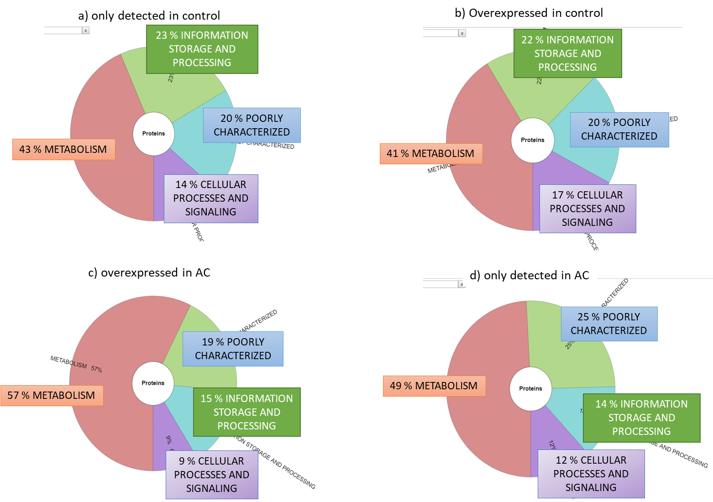

**Figure 1.** Overview ofthe COG general functional classifications for the proteins only detected in the control assay without material (a), overexpressed in the control assay (b), overexpressed in the assay with 0.5 g/L AC (c) and only detected in the assay with AC (d).

Figure 2 shows a more detailed representation of the data in figure 1, with its representation at the COG functional level. The differences at this level detail the differences at the COG general level, with more proteins involved in Energy Production and Conversion overexpressed in AC and more focus on processes related to Translation, ribosomal structure and biogenesis, Transcription and Replication, recombination and repair in the control sample.

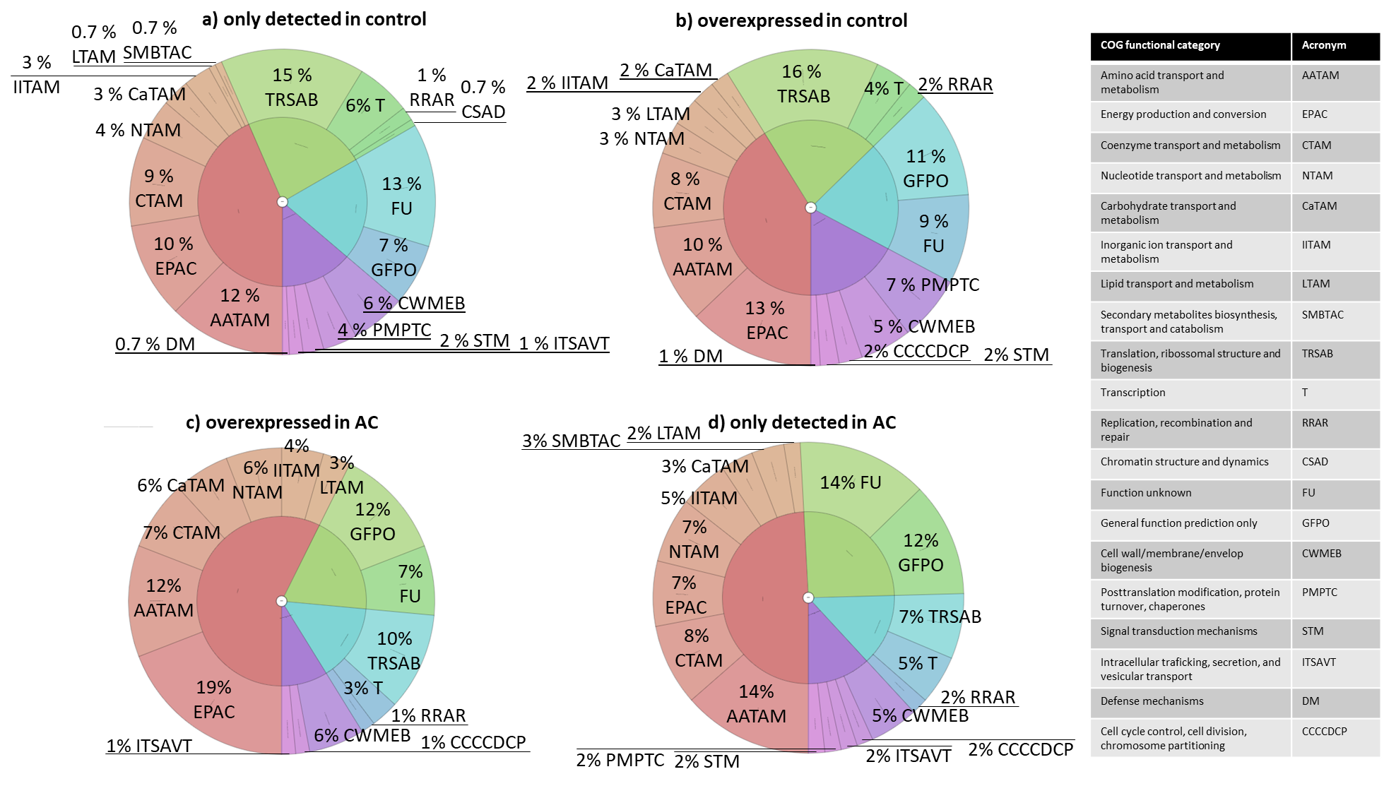

Figure 2 - Overview of the COG functional classifications for the proteins only detected in the control assay without material (a), overexpressed in the control assay (b), overexpressed in the assay with 0.5 g/L AC (c) and only detected in the assay with AC (d).

## **Distribution of proteins by different categories**

In order to investigate better the set of proteins detected during initial methane production in each condition (with and without AC), the data was divided by different categories that were established according to the role of protein in the cell. The following categories were considered regarding proteins’ roles:

* Methanogenesis pathway;
* Membrane and cellular envelop;
* Extracellular structures;
* Electron transport;
* Stress response;
* Growth factors.

### **Proteins involved in methanogenesis pathway**

55 proteins classified as belonging to methanogenesis, 32 detected.

### **Proteins related to membrane and cellular envelop**

574 proteins classified as belonging to membrane and cellular envelop, 53 detected.

### **Proteins in extracellular structures**

6 proteins classified as belonging to extracellular structures, 1 detected

### **Proteins involved in electron transport**

10 proteins classified as belonging to electron transport, 4 detected.

* F420H2 oxidase FprA (Type A flavoprotein FprA) (found in AC)
  + **Entry:** A0A090I360
  + **Genes**: Protein existence: predicted
  + **Gene ontology (GO):** electron transfer activity [GO:0009055]; FMN binding [GO:0010181]; metal ion binding [GO:0046872]
  + **COG general function category**: METABOLISM
  + **COG functional category**: Energy production and conversion
  + **COG protein description**: Uncharacterized flavoproteins
  + **COG**: COG0426
  + **Number of spectra detected in AC assay**: 27
  + **Keywords**: Complete proteome; Oxidoreductase

### **Stress proteins**

28 proteins classified as stress proteins, 5 detected.

Heat shock proteins are associated with the concept of stress proteins.

* Heat shock protein Hsp20 (Heat shock protein Hsp20/alpha crystallin family) (found in both, more in the control)
  + **Entry:** A0A089ZV28
  + **Genes:** Protein existence: predicted
  + **COG general function category:** CELLULAR PROCESSES AND SIGNALING
  + **COG functional category:** Posttranslational modification, protein turnover, chaperones
  + **COG protein description:** Molecular chaperone (small heat shock protein)
  + **COG:** COG0071
  + **Number of spectra detected in control assay**: 32
  + **Number of spectra detected in AC assay**: 15
  + **Keywords**: Complete proteome; Stress response

### **Growth factors proteins**

6 proteins classified as growth factors, 4 detected.

### **Summary of differential expression organized by protein categories**

Protein expression differences were comprehensively organized in table 5

Table 5 - Protein categories and respective differential expression between control and AC conditions. Greener boxes correspond to proteins more expressed in AC, red correspond to proteins more expressed in control.



## **Interesting proteins detected in AC condition**

During the analysis of proteins detected in the assay with 0.5 g/L of activated carbon, it was detected the presence of the following proteins which are absent in the control assay (without AC):

* Coenzyme F390 synthetase FtsA2 (Phenylacetate-coenzyme A ligase)
  + **EC number:** EC 6.2.1.30
  + **Entry:** A0A090I1N1
  + **Genes:** paaK1 ftsA2 paaK3 BRM9_0536 DSM1535_0517 MB9_1574
  + **Protein existence:** predicted
  + **Gene ontology (GO):** phenylacetate-CoA ligase activity [GO:0047475]; phenylacetate catabolic process [GO:0010124]
  + **COG general function:** Metabolism
  + **COG functional category:** Coenzyme transport and metabolism
  + **COG protein description:** Coenzyme F390 synthetase
  + **COG:** COG1541
  + **Number of spectra detected:** 89
  + **Some research**: (keywords: complete proteome; ligase)

Obligatory anaerobic methanogens usually contain high concentrations of the blue fluorescent coenzyme F420 (a cofactor), which takes a central position as the electron carrier in the methanogenic pathway and in other biosynthetic reactions (Vermeij et al., 1996, 1994). However, it seems that when cells are exposed to air (i.e., oxygen), this coenzyme F420 is converted into its 8-hydroxy-AMP (coenzyme F390-A) and 8-hydroxy-GMP (coenzyme F390-G) esters (Vermeij et al., 1996, 1994). The reaction is reversible, so when anoxic conditions are re-established, the coenzyme F390 (produced by cells exposed to air) is reconverted into F420. Enzymatic studies demonstrated that the formation and degradation of coenzyme F390(-A) is controlled by the activity of two enzymes in an antagonistic way:

* coenzyme F390 synthetase, which catalyses the ATP-dependent formation of coenzyme F390-A from coenzyme F420. This enzyme was observed as being inactive in anaerobic cell-free extracts and its activity was only found after treatment of the extracts with air. It is strongly inhibited by reduced coenzyme F420 (thus, the ratio of reduced and oxidized coenzyme F420 regulates the activity of the coenzyme F390 synthetase);
* and coenzyme F390 hydrolase, which cleaves the AMP residue from coenzyme F390, requires reducing conditions for activity. At low redox potential, the enzyme showed optimal activity, while an increasing in redox potential reduced its activity (Vermeij et al., 1996, 1994).

The role of coenzyme F390 in methanogenic metabolism is uncertain and the capability of producing this coenzyme appears to be restricted to some methanogenic species. Different functions have been proposed, such as: coenzyme F390 synthesis could provide a defensive mechanism to the microorganism against oxygen toxicity by restricting damaging interactions of reduced electron carriers with oxygen (its presence can be a signal of presence of oxygen); could be an artefact caused by cell death; or could be a substrate for unknown reactions. However, no clear correlation exists between oxygen tolerance and the presence of coenzyme F390 (Vermeij et al., 1994).

A study about this coenzyme was carried out where coenzyme F390 synthetase activity was routinely tested with ATP as the substrate yielding coenzyme F390-A as the product. The result suggested that the enzyme is capable of both coenzymes F390-A and F390-G synthesis. The coenzyme F390 synthetase reaction required Mg2+ as an additional substrate. High concentrations of salts (e.g., NaCl) are inhibitory for the activity of this enzyme. Apparently, a prior exposure to oxygen or oxidative conditions is not required for activation of the enzyme (Vermeij et al., 1994).

When the coenzyme F420H2 is exposed to air occurs its (nearly) complete oxidation to coenzyme F420. Then, coenzyme F390 synthetase appears. So, the observations suggested that F420H2 acts as inhibitor of the synthetase reaction and appears to be a potential competitive inhibitor regarding the coenzyme F420. This latter finding could explain why coenzyme F390 could only be detected in growing cells after exposure to oxygen and the reason why F390 synthetase activity could only be detected in cell extracts after exposure to air. In another words, coenzyme F420H2, present in methanogenic cells, in the presence of O2 is oxidized (by the action of the coenzyme F420-dependent hydrogenase to allow the synthetase reaction to occur), which annuls its inhibitory effect and allows the synthesis of coenzyme F390 (Vermeij et al., 1994).

In summary, the cellular concentration of coenzyme F390 depends of the antagonistic activities of coenzyme F390 synthetase (which is Mg2+ dependent - as the counter ion of ATP, optimal pH of 6, low-salt concentration and stimulated in phosphate buffer) and coenzyme F390 hydrolase (which requires Mn2+, optimal pH of 8.2, high-salt concentration and phosphate is inhibitory). In addition, the hydrolase is only active under anaerobic condition and reducing agents like dithiothreitol strongly stimulate the enzyme activity. On the other hand, coenzyme F390 synthetase activity depends of the ration between coenzyme F420 and coenzyme F420H2 (which is defined by H2 conditions and exposition to air). It is considered that coenzyme F390 synthetase and coenzyme F390 hydrolase reactions can provide a sort of sensor system in methanogens as a way of measuring the oxidation and reduction potential in the cells. So, coenzyme F390 presence occurs after the increasing of redox potential in the cell and perhaps may function as a signal compound, transferring information about the redox potential to a yet unknown site of action. This way, the presence of coenzyme F390 after oxidative stress could work as a signal of alarm that will trigger a stress response (Vermeij et al., 1996, 1994).

* Anaerobic ribonucleoside-triphosphate reductase (Anaerobic ribonucleoside-triphosphate reductase NrdD)
  + **EC number:** EC 1.17.4.2
  + **Entry:** A0A090JW98
  + **Genes:** nrdD BRM9_0145 DSM1535_1468 MB9_0109
  + **Protein existence:** predicted
  + **Gene ontology (GO):** ATP binding [GO:0005524]; ribonucleoside-triphosphate reductase activity [GO:0008998]; DNA replication [GO:0006260]
  + **COG general function category:** Metabolism
  + **COG functional category:** Nucleotide transport and metabolism
  + **COG protein description:** Oxygen-sensitive ribonucleoside-triphosphate reductase
  + **COG:** COG1328
  + **Number of spectra detected:** 64
  + **Some research:** (keywords: ATP-binding; Complete proteome; Nucleotide-binding; Oxidoreductase)

“Ribonucleotide reductases catalyze the synthesis of the four deoxyribonucleoside triphosphates (dNTPs) required for DNA replication (1-4). The enzymes provide a link between RNA and DNA metabolism.”

<https://www.ncbi.nlm.nih.gov/pmc/articles/PMC53890/pdf/pnas01034-0068.pdf>

“The NrdD reductase is activated by a tightly associated activase enzyme (NrdG) under anaerobic conditions [[Sun95](http://www.ncbi.nlm.nih.gov/pubmed/7852304)] and is inactivated by oxygen. Exposure to oxygen results in C-terminal truncation of the protein [[Sun93](http://www.ncbi.nlm.nih.gov/pubmed/8421692)] by cleavage on the N-terminal side of the glycyl radical at position 681 [[King95](http://www.ncbi.nlm.nih.gov/pubmed/7826394)]. Activation of the enzyme involves generation of a glycine radical at the C2 position of Gly681 [[Sun93](http://www.ncbi.nlm.nih.gov/pubmed/8421692), [Sun96a](http://www.ncbi.nlm.nih.gov/pubmed/8636106)]. A G681A mutant lacks the glycyl radical and has no enzymatic activity [[Sun96a](http://www.ncbi.nlm.nih.gov/pubmed/8636106)]. A multi-component system is responsible for activation of the enzyme. Electrons are transferred from NADPH by [flavodoxin/ferredoxin-NADP+ reductase](https://biocyc.org/gene?orgid=ECOLI&id=FLAVONADPREDUCT-MONOMER) to flavodoxin [[Bianchi93](http://www.ncbi.nlm.nih.gov/pubmed/8267617), [Bianchi93a](http://www.ncbi.nlm.nih.gov/pubmed/8449868)].”

“This enzyme is a class III ribonucleotide reductase that is essential for anaerobic growth.”

<https://biocyc.org/gene?orgid=ECOLI&id=RIBONUCLEOSIDE-TRIP-REDUCT-MONOMER>

* PAS/PAC sensor protein (Putative PAS/PAC sensor protein) (Response regulator/PAS domain-containing protein)
  + **Entry:** A0A089ZI47
  + **Genes:** BRM9_1398 DSM1535_2097 MB9_0912
  + **Protein existence:** predicted
  + **Gene ontology (GO):** phosphorelay signal transduction system [GO:0000160]
  + **COG general function category:** CELLULAR PROCESSES AND SIGNALING
  + **COG functional category:** Signal transduction mechanisms
  + **COG protein description:** FOG: CheY-like receiver
  + **COG:** COG0784
  + **Number of spectra detected:** 46
  + **Some research**: (keywords: Coiled coil; Complete proteome; Phosphoprotein)

PAS domains are considered important signalling modules whose function relies on monitoring changes in light, redox potential, oxygen, small ligands, and overall energy level of a cell. Signal-transducing proteins possess a PAS domain inside the cell, which senses redox changes in the electron transport system or overall cellular redox status. In addition, PAS domains can also sense environmental factors that cross the membrane of cell and/or affect cell’ metabolism. Having the capacity of sensing this type of changes can be advantageous for cells to survive. For example, oxygen is both a terminal acceptor for oxidative phosphorylation with its high ATP yield and a toxic agent which forms harmful reactive free radicals when partially reduced. The metabolic effects of oxygen, light, proton motive force, and redox potential are interrelated on the level of the flow of reducing equivalents through the electron transport system. Thus, it is enough for individual cells to sense any one of these parameters to monitor cell energy levels. For instance, cells that have enzyme reactions that are inactivated by oxygen are favoured if they possess the ability of sensing directly the oxygen. On the other hand, sensing of proton motive force or redox potential may provide a more versatile measure of cellular energy. PAS domains are found predominantly in proteins that are involved directly or indirectly in signal transduction. In a signaling pathway, the receptor interacts with a stimulus and transduces a signal that can be processed by the cell (Taylor and Zhulin, 1999).

**Examples:** “Of the PAS proteins that sense light, PYP is a receptor in which blue light is captured by the 4-hydroxycinnamyl chromophore in the PAS domain. FixL is an oxygen receptor, in which oxygen binds directly to a heme that is coordinated to a histidine residue within a PAS domain. Other PAS proteins, such as Aer, are transducers that sense oxygen indirectly by sensing redox changes as the electron transport system responds to changes in oxygen concentration.” (Taylor and Zhulin, 1999)

“Most PAS domains in prokaryotes are in histidine kinase sensor proteins. The prototypical two-component regulatory system consists of a histidine kinase sensor and cognate response regulator.” (Taylor and Zhulin, 1999)

“The specificity of a PAS domain for detection of input signals is determined, in part, by the cofactor associated with the PAS domain.” Exemplo: FAD (Taylor and Zhulin, 1999)

“In prokaryotes, PAS domains are mostly input domains for sensor kinases in two-component regulatory systems. The input domain may be in a separate protein. Some of the proteins with PAS input domains are global regulators of metabolism.” (Taylor and Zhulin, 1999)

“… BRM9 has a large number of genes encoding components of histidine kinase/response regulator signal transduction systems. Many of these proteins include 1–5 PAS domains. These are believed to monitor changes in redox potential, oxygen, and the overall energy level of the cell.” (Kelly et al., 2014)

Genoma *M. formicicum* 1535: (Maus et al., 2014)

### **Same COGs functions, different proteins**

Apparently the proteins mentioned above were not detected in the control assay without the presence of AC, but other proteins present in the control assay may perform the same COG function. For example, the following cases have the same COG of the protein PAS/PAC sensor protein only found in AC assay:

* Response regulator receiver protein (only detected in control assay)
  + **Entry**: A0A090I4Q1
  + **Genes**: DSM1535_2105
  + **Protein existence**: predicted
  + **Gene ontology (GO):** phosphorelay signal transduction system [GO:0000160]
  + **COG general function category**: CELLULAR PROCESSES AND SIGNALING
  + **COG functional category**: Signal transduction mechanisms
  + **COG protein description**: FOG: CheY-like receiver
  + **COG:** COG0784
  + **Number of spectra detected**: 31
  + **Keywords**: Complete proteome; Phosphoprotein
* Response regulator domain-containing protein (found in both conditions)
  + **Entry:** A0A089ZHU8
  + **Genes:** BRM9_1223 DSM1535_1904 MB9_1091
  + **Protein existence**: predicted
  + **Gene ontology (GO):** phosphorelay signal transduction system [GO:0000160]
  + **COG general function category**: CELLULAR PROCESSES AND SIGNALING
  + **COG functional category**: Signal transduction mechanisms
  + **COG protein description:** FOG: CheY-like receiver
  + **COG**: COG0784
  + **Number of spectra detected in control assay**: 28
  + **Number of spectra detected in AC assay:** 22
  + **Keywords:** Coiled coil; Complete proteome; Phosphoprotein

The presence of this kind of proteins are a little bit more detected when AC is present in the microbial environment (although it would be necessary replicates for each assay to confirm this).

# **References**

Kelly, W.J., Leahy, S.C., Li, D., Perry, R., Lambie, S.C., Attwood, G.T., Altermann, E., 2014. The complete genome sequence of the rumen methanogen Methanobacterium formicicum BRM9. Stand. Genomic Sci. 1–8.

Maus, I., Stantscheff, R., Wibberg, D., Stolze, Y., Winkler, A., Pühler, A., König, H., Schlüter, A., 2014. Complete genome sequence of the methanogenic neotype strain Methanobacterium formicicum MF. J. Biotechnol. 192, 40–41. https://doi.org/10.1016/j.jbiotec.2014.09.018

Taylor, B.L., Zhulin, I., 1999. PAS Domains: Internal Sensors of Oxygen , Redox Potential , and Light. Microbiol. Mol. Biol. Rev. 63, 479–506.

Vermeij, P., Detmers, F.J.M., Broers, F.J.M., Keltjens, J.T., Van Der Drift, C., 1994. Purification and characterization of coenzyme F390 synthetase from Methanobacterium thermoautotrophicum (strain H). Eur. J. Biochem. 226, 185–191.

Vermeij, P., Steen, R.J.T.V.A.N.D.E.R., Keltjens, J.A.N.T., Vogels, G.D., Leisinger, T., 1996. Coenzyme F390 Synthetase from Methanobacterium thermoautotrophicum Marburg Belongs to the Superfamily of Adenylate-Forming Enzymes. J. Bacteriol. 178, 505–510.